**PROJECT REPORT**

**“ONLINE RESUME MART”**

**S**ubmitted by:

**Asmit Kumar**

**Registration. No: 80403107007**

**Programme: B-TECH (CSE)**

Under the Guidance of

**Er.Sanjeev Sharma Mr.Jagbinder Singh Bomrah**

**CSE/IT (Industry coordinator)**

**B.Tech, M.Tech (CSE)  
Associate Professor**

**Department Of CSE/IT**

**BIS College of Engineering and Technology**

**GAGRA,MOGA**

**July – December 2011**

**DECLARATION**

I hereby declare that the project work entitled “**Online Resume Mart**” is an authentic record of my own work carried out at HCL Infosystems Ltd., Sec-8, Noida requirements of Industry Internship project for the award of degree of____________(Relevant Degree ), BIS College of Engineering and technology, Gagra, Moga, under the guidance of Mr. Jagbinder Singh Bomrah(Company coordinator) and Er.Sanjeev Sharma (Associate Professor ), during July to December 2011).

**Date: _____________ (Signature of student)**

**Asmit Kumar**

**Reg No.:-80403107007**

Certified that the above statement made by the student is correct to the best of our knowledge and belief.

**Er.Sanjeev Sharma Mr.Jagbinder Singh Bomrah**

**Associate Professor (Industry Coordinator)**

**B.Tech, M.Tech (CSE)  
Associate Professor**

**H.O.D (CSE)**

**PREFACE**

The objective of the project is to design and develop Resume Mart which is a place for Job Seekers and Job Providers to meet. The Data base should collect also the minute details about the Job Seeker and Provider. Resume Mart is designed to collect multiple resumes from the Job Seeker. Resume Mart aim is to provide Job Provider with enormous amount of data. The aim of Designing and Implementing Job Seekers & Job Providers is to collect data from the user; he may a job seeker or a job provider. Both of them are potential clients to our Resume Mart. A user should be registered regardless of whether he is a job seeker or a provider. In this module we register the user and grab as many details as possible about the user.Designing and implementing Resume Database, job database is to create a resume for all his job seekers asking the details about the experience, education, skills, affiliations and references for the project.

**ACKNOWLEDGEMENT**

Besides my efforts, the success of the work depends on the encouragement and guidelines of many others. I take this opportunity to express my gratitude to the people who have been there in the successful completion of my training work.

I would like to show my greatest appreciation to the Project Coordinator, Mr. Jagbinder Singh Bomrah, Er.Sanjeev Sharma for their guidance. I thank them for their tremendous support and help. Without their encouragement and guidance, this training would not have materialized.

I am grateful for their constant support and help.

**COMPANY PROFILE**

**Organization Overview:**

HCL INFOSYSTEMS LTD. is one of the pioneers in the Indian IT market, with its origins in 1976. For over quarter of a century, we have developed and implemented solutions for multiple market segments, across a range of technologies in India. We have been in the forefront in introducing new technologies and solutions.

HCL INFOSYSTEMS LTD. is India’s premier hardware, services and ICT systems Integration Company offering a wide spectrum of ICT products that includes Computing, Storage, Networking, Security, Telecom, Imaging and Retail. HCL is a one-stop-shop for all the ICT requirements of an organization. India's leading System Integration and Infrastructure Management Services Organization, HCL has specialized expertise across verticals including Telecom, BFSI, e-Governance & Power. HCL has India's largest distribution and retail network, taking to market a range of Digital Lifestyle products in partnership with leading global ICT brands, including Apple, Cisco, Ericsson, Kingston, Kodak, Konica Minolta, Microsoft, Nokia, Toshiba, and many more.

**COMPANY PROFILE**

Company Profile  
  
**HCL INFOSYSTEMS LTD.**   
HCL INFOSYSTEMS is India’s premier information enabling company. Leveraging its 3 decades of expertise in total technology solutions, HCL INFOSYSTEMS offers value-added services in key areas such as system integration, networking consultancy and a wide range of support services.

HCL INFOSYSTEMS is among the leading players in all the segments comprising the domestic IT products, solutions and related services, which include PCs, Servers, Imaging, Voice & video solutions, Networking Products, TV and FM Broadcasting solutions, Communication solutions, System Integration, ICT education & training, Digital lifestyle

Solutions and Peripherals.   
  
HCL has a direct sales, channel sales and retail sales network pan India. Continuously meeting the ever increasing customer expectations and applications, its focus on integrated enterprise solutions has strengthened the HCL INFOSYSTEMS’ capabilities in supporting installation types ranging from single to large, multi-location, multi-vendor & multi-platform spread across India. HCL INFOSYSTEMS, today has a direct support force of over **3000+** members, is operational at **360+**locations across the country and is the largest such human resource of its kind in the IT business in India.   
HCL INFOSYSTEMS' manufacturing facilities are **ISO 9001 & ISO 14001** certified and adhere to stringent quality standards and global processes. With the largest installed PC base in the country, four indigenously developed and manufactured PC brands - 'Infiniti', 'BUSYBEE' 'Beanstalk' and ‘EZEEBEE’ - and its robust manufacturing facilities, HCL INFOSYSTEMS aims to further leverage its dominance in the PC market. It has been consistently rated as Top player in PC industry by IDC.   
  
The 'Infiniti' line of business computing products is incorporated with leading edge products from world leaders such as Intel. Constant innovation to meet the customized requirements of its customers has enabled HCL to create the trusted ICT infrastructure platforms, powerful value adds like HCL Embedded Control & Continuity (HCL EC2) technology and the future generation of digital lifestyle enablers.  
  
The Imaging, Voice & video solutions segment has strategic alliances with industry leaders to provide services in various domains which include Audio Video system integration solutions, broadcasting solutions, imaging products and solutions. The company has strategic alliances with world leaders for voice and video conferencing solutions, TV and FM Broadcasting solutions and for Imaging products and solutions to provide documentation products like copiers, MFDs, laser printers and large format printers.  
  
The Channel Business of HCL INFOSYSTEMS has an extensive network of over **3000+** resellers across **900** locations. It has actively promoted the penetration of PCs in the home and the small office/home office (SOHO) segments.  
  
HCL INFINET LTD, 100% owned subsidiary of HCL INFOSYSTEMS Ltd. is a class A ISP focusing on providing the corporate networking services like Virtual Private Network, Broadband Internet Access, Internet Telephony Hosting & Co-location services, designing & deploying Disaster Recovery Solutions & Business Continuity solution, Application Services, Managed Security Services & NOC Services over its state-of-the-art IP / MPLS network and end-to-end contact centre solutions.   
Further information can be found at company’s website <www.hclinfosystems.in>  
  
**COMPANY LOGO**  
http://www.hclinfosystems.in/img/hcl-blue.jpg

**ABOUT COMAPNY CHAIRMAN & CEO (Mr. AJAI CHOUDHARY):**

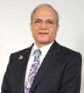

An engineer by training, **AJAI CHOUDHARY** is one of the six founder members of HCL and took over the reins of **HCL INFOSYSTEMS**, the flagship company of the group, as President and CEO in 1994. He was appointed the Chairman of **HCL INFOSYSTEMS** in November 1999. In recognition of his contribution in championing the cause of the domestic Indian IT industry, AJAI has been conferred the DATAQUEST ‘IT Man of the Year 2007’ Award amongst other awards.

**Manufacturing**



**Driven by a strong Manufacturing Objective**

**"WE SHALL DELIVER DEFECT-FREE PRODUCTS, SERVICES AND SOLUTIONS TO MEET THE REQUIREMENTS OF OUR EXTERNAL AND INTERNAL CUSTOMERS, THE FIRST TIME, EVERY TIME."**

All processes in the manufacturing are aligned to this guiding objective. A strong emphasis of **"Quality by Process"** is ensured across all processes. The products manufactured here undergo stringent tests that ensures their ruggedness & durability , which may be deployed anywhere in India and may have to face severe conditions like - heat , humidity , rough transportation & handling .Our products undergo drop tests , hot & cold temperature chamber , client-site simulation tests , reliability tests et al .  
  
Computers are shipped to locations all over India with an extensive network of professional logistic support partners. There is also a Customer satisfaction cell, in plant, to take care of problems reported from field.   
  
Customers, sales & marketing, support personnel, dealers & distributors are encouraged to visit the plant to see, for them, what all goes in making a quality computer system.

**Relationship Programme**

  
  
**HCL strongly believes in the power of relationships and partnership**   
  
No matter the size of your business, partnering with HCL INFOSYSTEMS will help you succeed. Leveraging over three decades of experience in total technology solutions, it’s our commitment to help you be as successful as possible.  
  
We provide you access to HCL’s innovative technologies, marketing strategies and value added services. By working on every aspect of the ICT industry, we have the experience to create world class products and services to help you give the best to your customers.

**Advantage HCL**

* HCL's labs - Pioneers in design, development and building ICT products
* India's largest Hardware, System Integration, Networking Solutions & Distribution Company
* 3 decades of expertise in technology solutions
* Partners with leading global players to provide the best of solutions to end users
* The largest manufacturer of PCs and Laptops in India
* Largest direct sales, digital lifestyle product distribution and retail network
* Extensive service network that reach out to 4,000 towns

**Reliable IT Backbone**  
  
In a world where the right technology infrastructure is a prerequisite, we offer a reliable IT backbone to our partners. HCL combines technical innovation with built-in reliability to keep your business running. We provide a one stop shop for meeting end-to-end IT requirements, thus offering a smooth ICT management.   
  
Additionally, we offer industry leading technology, designed to deliver a price to performance advantage to help you provide increased benefits to your customers. Our high-quality products and services give you means to work in a smarter way and be more productive and competitive.   
  
**Extensive Marketing Support**  
  
HCL has closely seen the IT industry rise from scratch, and has actively participated in its progress. We have picked up valuable marketing lessons in serving the IT needs of the Indian customers. You can combine your individual strengths and reputation with the power of a global brand.   
  
We can help you to focus on some of the most critical marketing needs facing your business. Additionally, we can provide you a set of proven sales and marketing tools designed to help you generate new leads, increased demands for products and services and help you reach your business goals.

**COMPANY VISION AND MISSION**

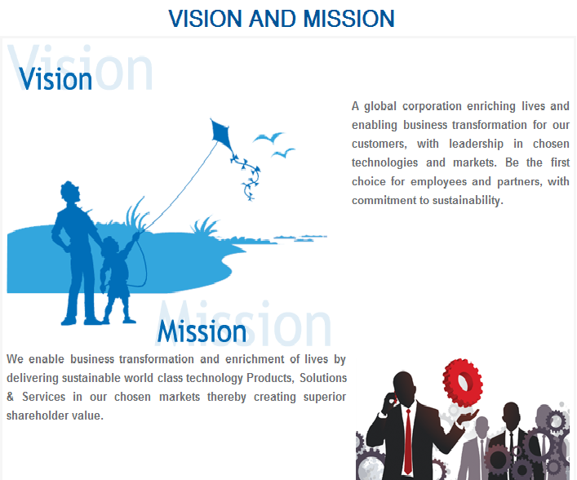

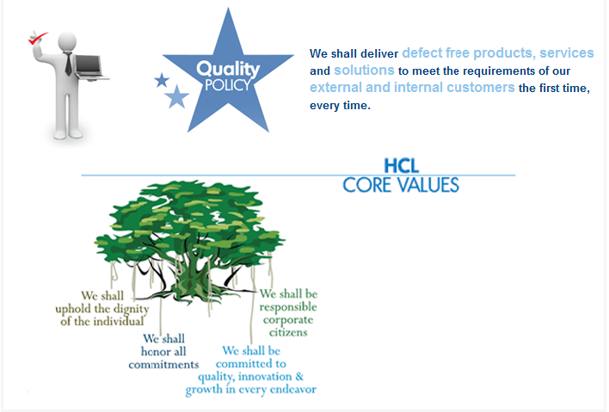

**INTRODUCTION TO THE PROJECT**:

The objective of the project is to design and develop Resume Mart which is a place for Job Seekers and Job Providers to meet. The Data base should collect also the minute details about the Job Seeker and Provider.

Resume Mart is designed to collect multiple resumes from the Job Seeker. Resume Mart aim is to provide Job Provider with enormous amount of data.

**System:**

**1. Designing and Implementing Job Seekers & Job Providers:**

The aim of this module is to collect data from the user; he may a job seeker or a job provider. Both of them are potential clients to our Resume Mart. A user should be registered regardless of whether he is a job seeker or a provider. In this module we register the user and grab as many details as possible about the user.

**2. Designing and implementing Resume Database, job database**

The aim of the module is to create a resume for all his job seekers asking the details about the experience, education, skills, affiliations and references for the project.

1. **designing a job search engine**

The aim of the module is to design a dynamic search engine for the Resume Mart data base which can provide data for the job seekers and job providers.

**SYSTEM ANALYSIS**

# Definition and reason for Condition Analysis

System analysis will be performed to determine if it is feasible to design an information based on policies and plans of the organization and on user requirements and to eliminate the weaknesses of the present system.

General requirements are: -

1. The new system should be cost effective.
2. To augment management, improve productivity and services.
3. To enhance User/System interface.
4. To improve information qualify and usability.
5. To upgrade system’s reliability, availability, flexibility and growth potential.

**IDENTIFICATION OF NEED**

Online Resume Mart maintains information about the different job providers as well as the job seekers. It notifies every job seeker with the availability of the job as per the category in which the job seeker has registered user’s resume. The system also notifies the job provider with the information about the persons registered under the category required by the job provider. It also maintains a specialized search engine which provides instant availability of the jobs as the user’s category. The system maintains information of the users who have registered with the site and every user can post multiple resumes in every category. The system helps the user in formulating the resume in proper manner.

After searching the required job on the site the seekers can directly forward their resume to the corresponding email address listed in the search. This kind of functionality is again provided to the job provider who can instantly mail the candidates if one falls under their category.

**FEASIBILITY STUDY**

**TECHINICAL FEASIBILITY:**

Evaluating the technical feasibility is the trickiest part of a feasibility study. This is because, at this point in time, not too many detailed design of the system, making it difficult to access issues like performance, costs on (on account of the kind of technology to be deployed) etc.

A number of issues have to be considered while doing a technical analysis.

1. **Understand the different technologies involved in the proposed system:**

Before commencing the project, we have to be very clear about what are the

technologies that are to be required for the development of the new system.

1. **Find out whether the organization currently possesses the required technologies:**

Is the required technology available with the organization?

If so is the capacity sufficient? For instance – “Will the current printer be able to handle the new reports and forms required for the new system?”

**OPERATIONAL FEASIBILITY:**

Proposed projects are beneficial only if they can be turned into information systems that will meet the organizations operating requirements. Simply stated, this test of feasibility asks if the system will work when it is developed and installed. Are there major barriers to Implementation? Here are questions that will help test the operational feasibility of a project:

* Is there sufficient support for the project from management from users? If

the current system is well liked and used to the extent that persons will not be

able to see reasons for change, there may be resistance.

* Are the current business methods acceptable to the user? If they are not,

Users may welcome a change that will bring about a more operational and useful systems.

* Have the user been involved in the planning and development of the project?

Early involvement reduces the chances of resistance to the system and in

General and increases the likelihood of successful project.

Since the proposed system was to help reduce the hardships encountered

In the existing manual system, the new system was considered to be operational feasible.

**ECONOMIC FEASIBILITY:**

Economic feasibility attempts 2 weigh the costs of developing and implementing a new system, against the benefits that would accrue from having the new system in place. This feasibility study gives the top management the economic justification for the new system.

A simple economic analysis which gives the actual comparison of costs and benefits are much more meaningful in this case. In addition, this proves to be a useful point of reference to compare actual costs as the project progresses. There could be various types of intangible benefits on account of automation. These could include increased customer satisfaction, improvement in product quality better decision making timeliness of information, expediting activities, improved accuracy of operations, better documentation and record keeping, faster retrieval of information, better employee morale.

**SOFTWARE REQUIREMENT SPECIFICATION**

**REQUIREMENT SPECIFICATION**:

The software, Online Resume Mart, which is designed for administrating & automating all the major activities that are carried out in an Resuem site to increase the efficiency of the Agency in order to provide better service to the Job Seekers and Job Providers.

### INTRODUCTION

**Purpose:** The main purpose for preparing this document is to give a general insight into the analysis and requirements of the existing system or situation and for determining the operating characteristics of the system.

**Scope:** This Document plays a vital role in the development life cycle (SDLC)

As it describes the complete requirement of the system. It is meant for use by the developers and will be the basic during testing phase. Any changes made to the requirements in the future will have to go through formal change approval process.

## Developers Responsibilities Overview :

The developer is responsible for:

1) Developing the system, which meets the SRS and solving all the requirements of the system.

2) Demonstrating the system and installing the system at client's location after the acceptance testing is successful.

3) Submitting the required user manual describing the system interfaces to work on it and also the documents of the system.

4) Conducting any user training that might be needed for using the system.

5) Maintaining the system for a period of one year after installation.

## Functional Requirements:

**Inputs:** The major inputs for Online Resume Mart can be categorized module -wise. Basically all the information is managed by the software and in order to access the information one has to produce one's identity by entering the user-id and password. Every user has his/her own domain of access beyond which the access is dynamically refrained rather denied.

**Output:** The major outputs of the system are tables and reports. Tables are created dynamically to meet the requirements on demand. Reports, as it is obvious, carry the gist of the whole information that flows across the institution.

This application must be able to produce output at different modules for different inputs.

**Performance Requirements:**

Performance is measured in terms of reports generated weekly and monthly.

**SOFTWARE AND HARDWARE SPECIFICATIONS**

**Hardware:**

**Processor** : Intel Pentium or more

# Ram : 256 MB or more

**Cache**  : 512 KB

**Hard disk**  : 16 GB hard disk recommended for primary

Partition.

**Software:**

**Operating system** : Windows 2000 or later

# Front End Software: BEA Weblogic Platform 8.1

**BackEnd Software** : MySQL

#### I/O REQUREMENTS

|  |  |
| --- | --- |
| KEYBOARD | STANDARD |
| MOUSE | STANDARD |
| MONITOR | VGA or XVGA |
| CD-ROM | 4X or above |

**SOFTWARE SPECIFICATION**

|  |  |
| --- | --- |
| WEB SERVER | Glassfish 6.0 or Apache Tomcat 6.0 or Weblogic |
| LANGUAGE | Core Java, Advance Java (JSP, SERVLETS) |
| DATABASE | MySQL |
| BROWSER | Internet Explorer, Firefox etc. |
| SCRIPTING LANGUAGE | HTML, JAVA Script |

#### TOOLS, PLATFORM/LANGUAGES USED

**Technology used**

**What is Java?**

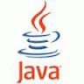

Java technology is both a programming language and a platform. The Java programming language is a high-level language that can be characterized by all of the following buzzwords:

* Simple
* Object Oriented
* Distributed
* Multithreaded
* Dynamic
* Architecture Neutral
* Portable
* High performance
* Robust
* Secure

# Java Platform, Enterprise Edition or Java EE is a widely used [platform](http://en.wikipedia.org/wiki/Platform_(computing)) for [server](http://en.wikipedia.org/wiki/Server_(computing))

# Programming in the [Java](http://en.wikipedia.org/wiki/Java_(programming_language)) programming language. The Java (Enterprise Edition) differs from the [Java Standard Edition Platform](http://en.wikipedia.org/wiki/Java_Platform,_Standard_Edition) (Java SE) in that it adds [libraries](http://en.wikipedia.org/wiki/Library_(computer_science)) which

# provide functionality to deploy fault-tolerant, [distributed](http://en.wikipedia.org/wiki/Distributed_computing), [multi-tier](http://en.wikipedia.org/wiki/Multitier_architecture) Java [software](http://en.wikipedia.org/wiki/Application_software), based largely on [modular](http://en.wikipedia.org/wiki/Modularity_(programming)) [components](http://en.wikipedia.org/wiki/Software_component) running on an [application server](http://en.wikipedia.org/wiki/Application_server).

The platform was known as Java 2 Platform, Enterprise Edition or J2EE until the name was changed to Java EE in version 5. The current version is called Java EE 6.

Java EE is defined by its [specification](http://en.wikipedia.org/wiki/Program_specification). As with other [Java Community Process](http://en.wikipedia.org/wiki/Java_Community_Process) specifications, providers must meet certain conformance requirements in order to declare their products as Java EE compliant.

Java EE includes several [API](http://en.wikipedia.org/wiki/Application_programming_interface) specifications, such as [JDBC](http://en.wikipedia.org/wiki/Java_Database_Connectivity), [RMI](http://en.wikipedia.org/wiki/Remote_Method_Invocation), [e-mail](http://en.wikipedia.org/wiki/E-mail), [JMS](http://en.wikipedia.org/wiki/Java_Message_Service), [web services](http://en.wikipedia.org/wiki/Web_service), XML, etc., and defines how to coordinate them. Java EE also features some specifications unique to Java EE for components. These include [Enterprise JavaBeans](http://en.wikipedia.org/wiki/Enterprise_JavaBean), [Connectors](http://en.wikipedia.org/wiki/Java_EE_Connector_Architecture), [Servlets](http://en.wikipedia.org/wiki/Servlet), [port lets](http://en.wikipedia.org/wiki/Portlet) (following the [Java Port let specification](http://en.wikipedia.org/wiki/Java_Portlet_specification)), [Java Server Pages](http://en.wikipedia.org/wiki/JavaServer_Pages) and several service technologies. This allows developers to create [enterprise applications](http://en.wikipedia.org/wiki/Enterprise_software) that are [portable](http://en.wikipedia.org/wiki/Porting) and [scalable](http://en.wikipedia.org/wiki/Scalability), and that integrate with legacy technologies. A Java EE [application server](http://en.wikipedia.org/wiki/Application_server) can handle transactions, security, scalability, [concurrency](http://en.wikipedia.org/wiki/Concurrency_(computer_science)) and management of the components that are deployed to it, in order to enable developers to concentrate more on the business logic of the components rather than on infrastructure and integration tasks.

**Net Beans Builder 7.0**



Net Beans refers to both a platform framework for Java desktop applications, and an integrated development environment (IDE) for developing with Java, JavaScript, PHP, Python, Ruby, Groovy, C, C++, SCALA, CLOJURE, and others (for a complete overview, visit the website net beans).

The Net Beans IDE is written in Java and runs everywhere where a JVM is installed, including Windows, Mac OS, Linux, and Solaris. A JDK is required for Java functionality, but is not required for development in other programming languages.

The Net Beans IDE is an open-source integrated development environment. Net Beans IDE supports development of all Java application types (Java SE including JavaFX, (Java ME, web, EJB and mobile applications) out of the box. Among other features are an Ant-based project system, Maven support, refactoring, version control (supporting CVS, Subversion, Mercurial and Clear case).

**Modularity:** Net Beans contains all the modules needed for Java development in a single download, allowing the user to start working immediately. Modules also allow Net Beans to be extended. New features, such as support for other programming languages, can be added by installing additional modules. For instance, Sun Studio, Sun Java Studio Enterprise, and Sun Java Studio Creator from Sun Microsystems are all based on the Net Beans IDE.

**Servlet:**



A Servlet is a [Java class](http://en.wikipedia.org/wiki/Java_class) in [Java EE](http://en.wikipedia.org/wiki/Java_EE) that conforms to the Java Servlet API, a protocol by which a Java class may respond to [HTTP](http://en.wikipedia.org/wiki/HTTP) requests. They are not tied to a specific client-server protocol, but are most often used with this protocol. The word "Servlet" is often used in the meaning of "HTTP Servlet". Thus, a [software developer](http://en.wikipedia.org/wiki/Software_developer) may use a servlet to add [dynamic content](http://en.wikipedia.org/wiki/Dynamic_web_page) to a [Web server](http://en.wikipedia.org/wiki/Web_server) using the [Java platform](http://en.wikipedia.org/wiki/Java_platform). The generated content is commonly [HTML](http://en.wikipedia.org/wiki/HTML), but may be other data such as [XML](http://en.wikipedia.org/wiki/XML). Servlets are the [Java](http://en.wikipedia.org/wiki/Java_(software_platform)) counterpart to non-Java dynamic Web content technologies such as [CGI](http://en.wikipedia.org/wiki/Common_Gateway_Interface) and [ASP.NET](http://en.wikipedia.org/wiki/Active_Server_Pages). Servlets can maintain [state](http://en.wikipedia.org/wiki/State_(computer_science)) in [session](http://en.wikipedia.org/wiki/Session_(computer_science)) variables across many server transactions by using [HTTP cookies](http://en.wikipedia.org/wiki/HTTP_cookie), or [URL rewriting](http://en.wikipedia.org/wiki/URL_rewriting).

The servlet [API](http://en.wikipedia.org/wiki/Application_programming_interface), contained in the [Java package](http://en.wikipedia.org/wiki/Java_package) hierarchy [javax.servlet](http://java.sun.com/javaee/6/docs/api/javax/servlet/package-summary.html), defines the expected interactions of a [Web container](http://en.wikipedia.org/wiki/Web_container) and a servlet.A Web container is essentially the component of a Web server that interacts with the servlets. The Web container is responsible for managing the lifecycle of servlets, mapping a URL to a particular servlet and ensuring that the URL requester has the correct access rights.

A [Servlet](http://java.sun.com/javaee/6/docs/api/javax/servlet/Servlet.html) is an [object](http://en.wikipedia.org/wiki/Object_(computer_science)) that receives a request and generates a response based on that request. The basic servlet package defines Java objects to represent servlet requests and responses, as well as objects to reflect the servlet's configuration parameters and execution environment. The package[javax.servlet.http](http://java.sun.com/javaee/6/docs/api/javax/servlet/http/package-summary.html) defines [HTTP](http://en.wikipedia.org/wiki/HTTP)-specific subclasses of the generic servlet elements, including session management objects that track multiple requests and responses between the Web server and a client. Servlets may be packaged in a [WAR file](http://en.wikipedia.org/wiki/WAR_(Sun_file_format)) as a [Web application](http://en.wikipedia.org/wiki/Web_application).

Servlets can be generated automatically from [JavaServer Pages](http://en.wikipedia.org/wiki/JavaServer_Pages" \o "JavaServer Pages) (JSP) by the [JavaServer Pages compiler](http://en.wikipedia.org/wiki/JavaServer_Pages_compiler" \o "JavaServer Pages compiler). The difference between Servlets and JSP is that Servlets typically embed HTML inside Java code, while JSPs embed Java code in HTML. While the direct usage of Servlets to generate HTML (as shown in the example below) is relatively rare nowadays, the higher level MVC web framework in Java EE ([JSF](http://en.wikipedia.org/wiki/Java_Server_Faces)) still explicitly uses the Servlet technology for the low level request/response handling via the FacesServlet. A somewhat older usage is to use servlets in conjunction with JSPs in a pattern called "[Model 2](http://en.wikipedia.org/wiki/Model_2)", which is a flavour of the [model-view-controller](http://en.wikipedia.org/wiki/Model-view-controller) pattern.

# JavaServer Pages Technology



JavaServer Pages (JSP) technology enables Web developers and designers to rapidly develop and easily maintain, information-rich, dynamic Web pages that leverage existing business systems. As part of the Java technology family, JSP technology enables rapid development of Web-based applications that are platform independent. JSP technology separates the user interface from content generation, enabling designers to change the overall page layout without altering the underlying dynamic content.

**Benefits for Developers**

|  |
| --- |
|  |

If you are a Web page developer or designer who is familiar with HTML, you can:

* **Use JSP technology without having to learn the Java language**: You can use JSP technology without learning how to write Java scriplets. Although scriptlets are no longer required to generate dynamic content, they are still supported to provide backward compatibility.
* **Extend the JSP language**: Java tag library developers and designers can extend the JSP language with "simple tag handlers," which utilize a new, much simpler and cleaner, tag extension API. This spurs the growing number of pluggable, reusable tag libraries available, which in turn reduces the amount of code needed to write powerful Web applications.
* **Easily write and maintain pages**: The [JavaServer Pages Standard Tag Library](http://www.oracle.com/technetwork/java/index-jsp-135995.html) (JSTL) expression language is now integrated into JSP technology and has been upgraded to support functions. The expression language can now be used instead of scriptlet expressions.

**JSP Technology and Java Servlets**

|  |
| --- |
|  |

JSP technology uses XML-like tags that encapsulate the logic that generates the content for the page. The application logic can reside in server-based resources (such as [JavaBeans component architecture](http://www.oracle.com/technetwork/java/javase/tech/index-jsp-138795.html)) that the page accesses with these tags. Any and all formatting (HTML or XML) tags are passed directly back to the response page. By separating the page logic from its design and display and supporting a reusable component-based design, JSP technology makes it faster and easier than ever to build Web-based applications.   
  
JavaServer Pages technology is an extension of the [Java Servlet technology](http://www.oracle.com/technetwork/java/index-jsp-135475.html). Servlets are platform-independent, server-side modules that fit seamlessly into a Web server framework and can be used to extend the capabilities of a Web server with minimal overhead, maintenance, and support. Unlike other scripting languages, servlets involve no platform-specific consideration or modifications; they are application components that are downloaded, on demand, to the part of the system that needs them. Together, JSP technology and servlets provide an attractive alternative to other types of dynamic Web scripting/programming by offering: platform independence; enhanced performance; separation of logic from display; ease of administration; extensibility into the enterprise; and, most importantly,easeofuse.   
  
Today servlets are a popular choice for building interactive Web applications. Third-party servlet containers are available for Apache Web Server, Microsoft IIS, and [others](http://www.oracle.com/technetwork/java/industry-136995.html). Servlet containers are usually a component of Web and application servers, such as BEA WebLogic Application Server, IBM WebSphere, [Sun Java System Web Server](http://wwws.sun.com/software/products/web_srvr/home_web_srvr.html), [Sun Java System Application Server](http://wwws.sun.com/software/products/appsrvr/home_appsrvr.html), and [others](http://www.oracle.com/technetwork/java/industry-136995.html).

**JSP Technology in the Java EE 5 Platform**

The focus of Java EE 5 has been ease of development by making use of Java language annotations that were introduced by J2SE 5.0. JSP 2.1 supports this goal by defining annotations for dependency injection on JSP tag handlers and context listeners.

Another key concern of the Java EE 5 specification has been the alignment of its webtier technologies, namely JavaServer Pages (JSP), JavaServer Faces (JSF), and JavaServer Pages Standard Tag Library (JSTL).

The outcome of this alignment effort has been the Unified Expression Language (EL), which integrates the expression languages defined by JSP 2.0 and JSF 1.1.

The main key additions to the Unified EL that came out of tbe alignment work have been:

* A pluggable API for resolving variable references into Java objects and for resolving the properties applied to these Java objects,
* Support for deferred expressions, which may be evaluated by a tag handler when needed, unlike their regular expression counterparts, which get evaluated immediately when a page is executed and rendered, and
* Support for lvalue expression, which appear on the left hand side of an assignment operation. When used as an lvalue, an EL expression represents a reference to a data structure, for example: a JavaBeans property, that is assigned some user input.

**Mysql:**



As the world's most popular open source database, MySQL is used by a wide range of organizations to manage their data.

**MySQL** officially, but also commonly is a [relational database management system](http://en.wikipedia.org/wiki/Relational_database_management_system) (RDBMS) that runs as a server providing multi-user access to a number of databases. It is named after developer [Michael Widenius](http://en.wikipedia.org/wiki/Michael_Widenius)' daughter, My The [SQL](http://en.wikipedia.org/wiki/SQL) phrase stands for Structured Query Language.

The MySQL development project has made its [source code](http://en.wikipedia.org/wiki/Source_code) available under the terms of the [GNU General Public License](http://en.wikipedia.org/wiki/GNU_General_Public_License), as well as under a variety of [proprietary](http://en.wikipedia.org/wiki/Proprietary_software) agreements. MySQL was owned and sponsored by a single [for-profit](http://en.wikipedia.org/wiki/Business) firm, the [Swedish](http://en.wikipedia.org/wiki/Sweden) company [MySQL AB](http://en.wikipedia.org/wiki/MySQL_AB), now owned by [Oracle Corporation](http://en.wikipedia.org/wiki/Oracle_Corporation).

[Free-software](http://en.wikipedia.org/wiki/Free_software)-open source projects that require a full-featured database management system often use MySQL. For commercial use, several paid editions are available, and offer additional functionality. Applications which use MySQL databases include: [TYPO3](http://en.wikipedia.org/wiki/TYPO3), [Joomla](http://en.wikipedia.org/wiki/Joomla), [WordPress](http://en.wikipedia.org/wiki/WordPress), [phpBB](http://en.wikipedia.org/wiki/PhpBB), [Drupal](http://en.wikipedia.org/wiki/Drupal) and other software built on the [LAMP](http://en.wikipedia.org/wiki/LAMP_%28software_bundle%29) software stack. MySQL is also used in many high-profile, large-scale [World Wide Web](http://en.wikipedia.org/wiki/World_Wide_Web) products, including [Wikipedia](http://en.wikipedia.org/wiki/Wikipedia), [Google](http://en.wikipedia.org/wiki/Google)

MySQL can be built and installed manually from source code, but this can be tedious so it is more commonly installed from a binary package unless special customizations are required. On most Linux distributions the [package management system](http://en.wikipedia.org/wiki/Package_management_system) can download and install MySQL with minimal effort, though further configuration is often required to adjust security and optimization settings.

Though MySQL began as a low-end alternative to more powerful proprietary databases, it has gradually evolved to support higher-scale needs as well. It is still most commonly used in small to medium scale single-server deployments, either as a component in a [LAMP](http://en.wikipedia.org/wiki/LAMP_%28software_bundle%29)-based web application or as a standalone database server. Much of MySQL's appeal originates in its relative simplicity and ease of use, which is enabled by an ecosystem of open source tools such as [phpMyAdmin](http://en.wikipedia.org/wiki/PhpMyAdmin). In the medium range, MySQL can be scaled by deploying it on more powerful hardware, such as a multi-processor server with gigabytes of memory.

There are however limits to how far performance can scale on a single server, so on larger scales, multi-server MySQL deployments are required to provide improved performance and reliability. A typical high-end configuration can include a powerful master database which handles data write operations and is [replicated](http://en.wikipedia.org/wiki/Replication_%28computer_science%29#Database_replication) to multiple slaves that handle all read operations.The master server synchronizes continually with its slaves so in the event of failure a slave can be promoted to become the new master, minimizing downtime. Further improvements in performance can be achieved by caching the results from database queries in memory using [memcached](http://en.wikipedia.org/wiki/Memcached), or breaking down a database into smaller chunks called [shards](http://en.wikipedia.org/wiki/Shard_%28database_architecture%29) which can be spread across a number of distributed server clusters

# Java Database Connectivity

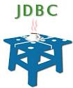

**JDBC** is a Java-based data access technology (Java Standard Edition platform) from Sun Microsystems, Inc.. It is not an acronym as it is unofficially referred to as **Java Database Connectivity**. This technology is an [API](http://en.wikipedia.org/wiki/Application_programming_interface) for the [Java programming language](http://en.wikipedia.org/wiki/Java_%28programming_language%29) that defines how a client may access a [database](http://en.wikipedia.org/wiki/Database). It provides methods for querying and updating data in a database. JDBC is oriented towards [relational databases](http://en.wikipedia.org/wiki/Relational_database_management_system). A JDBC-to-[ODBC](http://en.wikipedia.org/wiki/Open_Database_Connectivity) bridge enables connections to any ODBC-accessible data source in the [JVM](http://en.wikipedia.org/wiki/JVM) host environment.

[Sun Microsystems](http://en.wikipedia.org/wiki/Sun_Microsystems) released JDBC as part of [JDK](http://en.wikipedia.org/wiki/Java_Development_Kit) 1.1 on February 19, 1997 It has since formed part of the [Java Standard Edition](http://en.wikipedia.org/wiki/Java_Platform,_Standard_Edition).

The JDBC classes are contained in the [Java package](http://en.wikipedia.org/wiki/Java_package) [java.sql](http://download.oracle.com/javase/7/docs/api/java/sql/package-summary.html) and [javax.sql](http://download.oracle.com/javase/7/docs/api/javax/sql/package-summary.html).

Starting with version 3.1 , JDBC has been developed under the [Java Community Process](http://en.wikipedia.org/wiki/Java_Community_Process). JSR 54 specifies JDBC 3.0 (included in J2SE 1.4), JSR 114 specifies the JDBC Rowset additions, and JSR 221 is the specification of JDBC 4.0 (included in Java SE 6)

## Functionality

JDBC allows multiple implementations to exist and be used by the same application. The API provides a mechanism for dynamically loading the correct Java packages and registering them with the JDBC Driver Manager.The Driver Manager is used as a connection factory for creating JDBC connections.

JDBC connections support creating and executing statements. These may be update statements such as [SQL](http://en.wikipedia.org/wiki/SQL)'s CREATE, INSERT, UPDATE and DELETE, or they may be query statements such as SELECT. Additionally, [stored procedures](http://en.wikipedia.org/wiki/Stored_procedures) may be invoked through a JDBC connection. JDBC represents statements using one of the following classes:

* [Statement](http://download.oracle.com/javase/7/docs/api/java/sql/Statement.html) – the statement is sent to the database server each and every time.
* [PreparedStatement](http://download.oracle.com/javase/7/docs/api/java/sql/PreparedStatement.html) – the statement is cached and then the execution path is pre determined on the database server allowing it to be executed multiple times in an efficient manner.
* [CallableStatement](http://download.oracle.com/javase/7/docs/api/java/sql/CallableStatement.html) – used for executing [stored procedures](http://en.wikipedia.org/wiki/Stored_procedures) on the database.

Update statements such as INSERT, UPDATE and DELETE return an update count that indicates how many rows were affected in the database. These statements do not return any other information.

Query statements return a JDBC row result set. The row result set is used to walk over the result set. Individual columns in a row are retrieved either by name or by column number. There may be any number of rows in the result set. The row result set has metadata that describes the names of the columns and their types.

There is an extension to the basic JDBC API in the [javax.sql](http://download.oracle.com/javase/7/docs/api/javax/sql/package-summary.html).

JDBC connections are often managed via a connection pool rather than obtained directly from the driver.

# BEA WebLogic Server



Owned by [Oracle Corporation](http://en.wikipedia.org/wiki/Oracle_Corporation), **Oracle WebLogic** consists of a [Java EE](http://en.wikipedia.org/wiki/Java_EE) platform product-family that includes:

* a Java EE [application server](http://en.wikipedia.org/wiki/Application_server), [WebLogic Application Server](http://en.wikipedia.org/wiki/WebLogic_Application_Server)
* an [enterprise portal](http://en.wikipedia.org/wiki/Enterprise_portal), WebLogic Portal
* an [Enterprise Application Integration](http://en.wikipedia.org/wiki/Enterprise_application_integration) platform
* a transaction server and infrastructure, [WebLogic Tuxedo](http://en.wikipedia.org/wiki/Tuxedo_%28software%29)
* a telecommunication platform, [WebLogic Communication Platform](http://en.wikipedia.org/w/index.php?title=WebLogic_Communication_Platform&action=edit&redlink=1)
* an [HTTP](http://en.wikipedia.org/wiki/Hypertext_Transfer_Protocol) [web server](http://en.wikipedia.org/wiki/Web_server)

BEA Weblogic is a J2EE Application Server. It is used to host webpages from simple types to secured webpages.  
It consists lot of builtin containers, options etc.. which is used to achieve this.  
  
Technically, it is where all our JSP's, Servlets, EJB's etc.. are deployed. Advanced concepts like load balancing, clustering etc.. are also supported by weblogic.

BEA Systems' WebLogic is a [server](http://whatis.techtarget.com/definition/0,,sid9_gci212964,00.html) software application that runs on a middle [tier](http://whatis.techtarget.com/definition/0,,sid9_gci213144,00.html), between [back-end](http://searchdatacenter.techtarget.com/sDefinition/0,,sid80_gci212161,00.html) [database](http://searchsqlserver.techtarget.com/sDefinition/0,,sid87_gci211895,00.html)s and related applications and [browser](http://searchwindevelopment.techtarget.com/sDefinition/0,,sid8_gci211708,00.html)-based [thin client](http://searchnetworking.techtarget.com/sDefinition/0,,sid7_gci213135,00.html)s. WebLogic is a leading [e-commerce](http://searchcio.techtarget.com/sDefinition/0,,sid182_gci212029,00.html) online transaction processing ([OLTP](http://searchdatacenter.techtarget.com/sDefinition/0,,sid80_gci214138,00.html) ) platform, developed to connect users in a [distributed](http://searchcio-midmarket.techtarget.com/sDefinition/0,,sid183_gci211967,00.html) computing environment and to facilitate the integration of [mainframe](http://searchdatacenter.techtarget.com/sDefinition/0,,sid80_gci212516,00.html) applications with distributed corporate data and applications.

WebLogic server is based on Java 2 Platform, Enterprise Edition ([J2EE](http://searchsoa.techtarget.com/sDefinition/0,,sid26_gci283984,00.html)), the standard platform used to create [Java](http://searchsoa.techtarget.com/sDefinition/0,,sid26_gci212415,00.html)-based multi-[tier](http://whatis.techtarget.com/definition/0,,sid9_gci213144,00.html) enterprise applications. J2EE platform technologies were developed through the efforts of BEA Systems and other vendors in collaboration with the main developer, Sun Microsystems. Because J2EE applications are standardized modules, WebLogic can automate many system-level tasks that would otherwise have demanded programming time.

The main features of WebLogic server include connectors that make it possible for any [legacy application](http://searchdatacenter.techtarget.com/sDefinition/0,,sid80_gci212472,00.html) on any client to interoperate with server applications, Enterprise JavaBean (EJB) components, resource pooling, and connection sharing that make applications very scalable. An administration console with a user interface makes management tasks more efficient and features such as Secure Sockets Layer (SSL) support for the encryption of data transmissions, as well as [authentication](http://searchsecurity.techtarget.com/sDefinition/0,,sid14_gci211621,00.html) and authorization mechanisms, make applications and transactions secure.

**SYSTEM DESIGN AND DFD**

**DESIGN NOTATIONS**

**Symbols Used in DFD:**

**Rectangle** Source/destination of data

**Bubble** Process for transformation data

**Arrows** Data in motion (data flow)

**Half Rectangle** Data Storage

**Oval**  Attributes

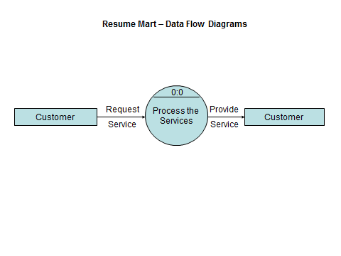

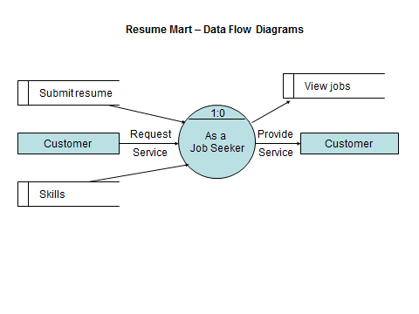

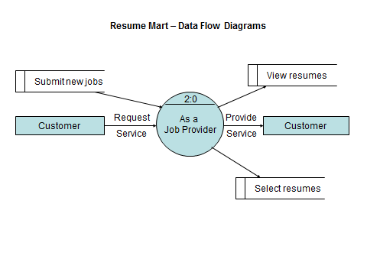

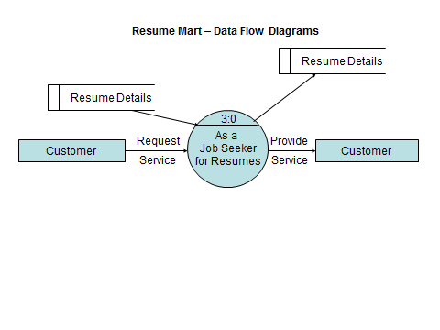

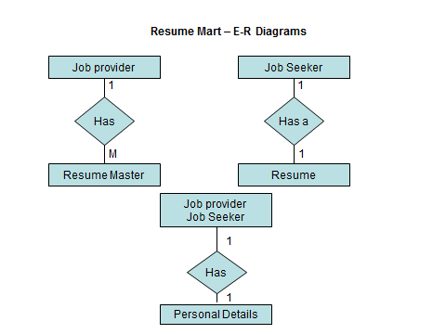

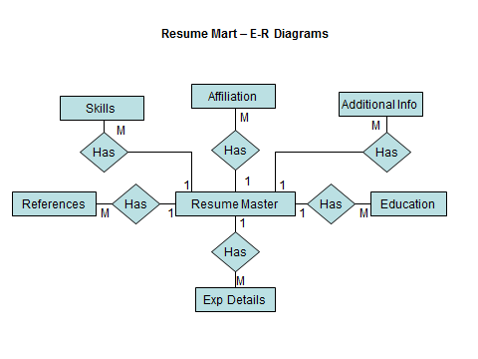

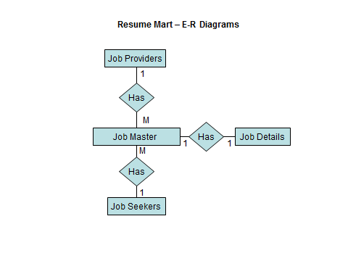

**FUTURE SCOPE OF THE PROJECT**

The project has met the standards required to work at pharmaceutical industry. If the business logic remains same the project can be ported to any pharmaceutical company with minor changes in the working procedure of the project. The project can be used as an availability to develop a project for a different company with different business logic wherein the commonalties in certain areas remain the same at any business level. By using the common features in future development the development time as well as the cost of development can be decreased considerably.

**SNAPSHOTS**

**Home Page:**

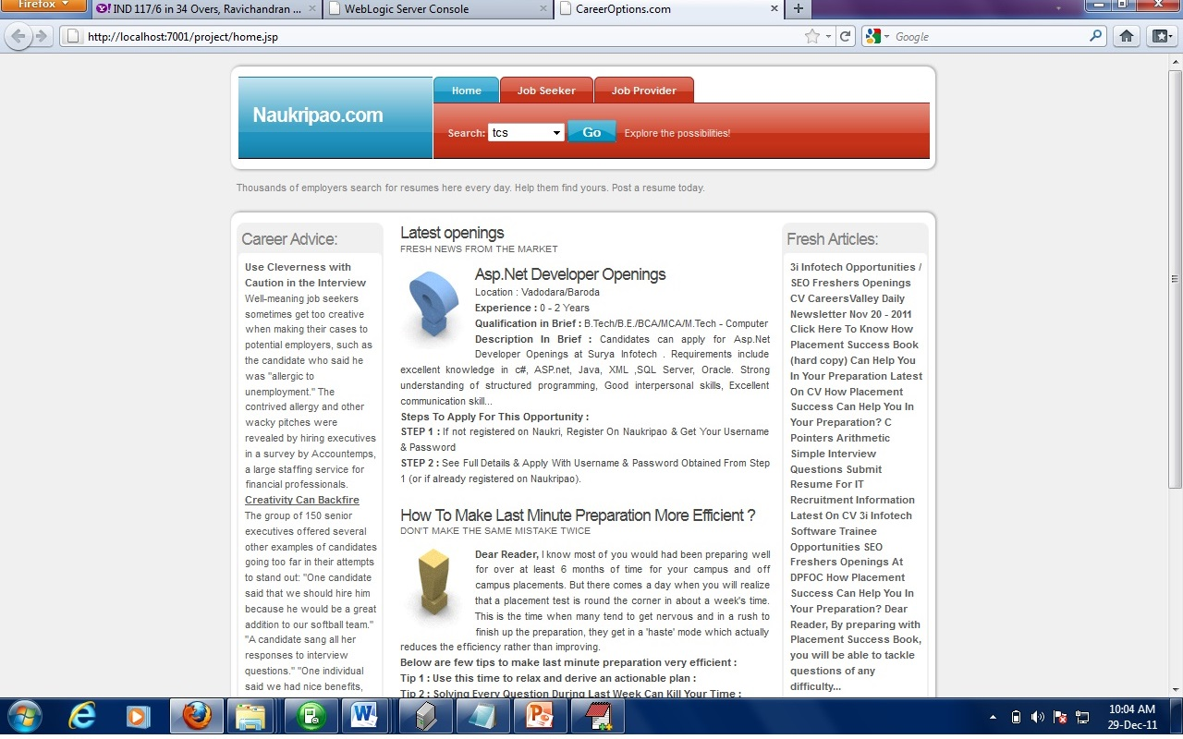

**Job Seeker Login and Registration**

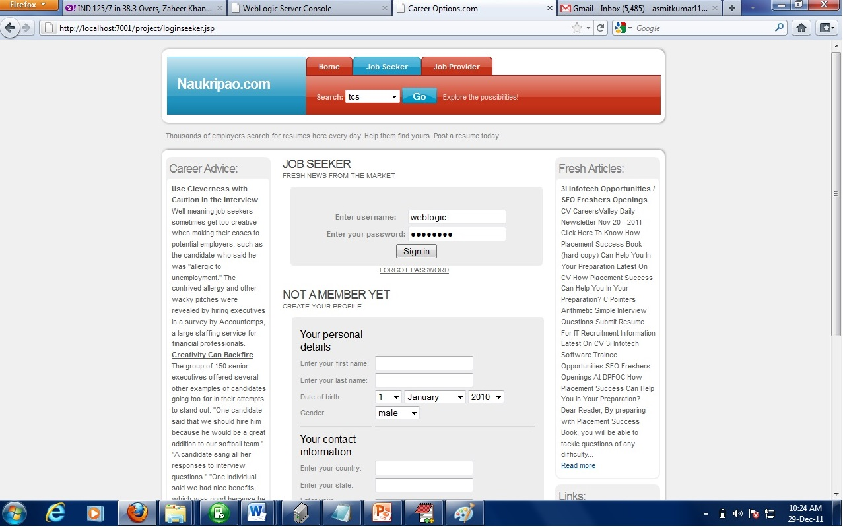

**Job Provider Login and Registration**

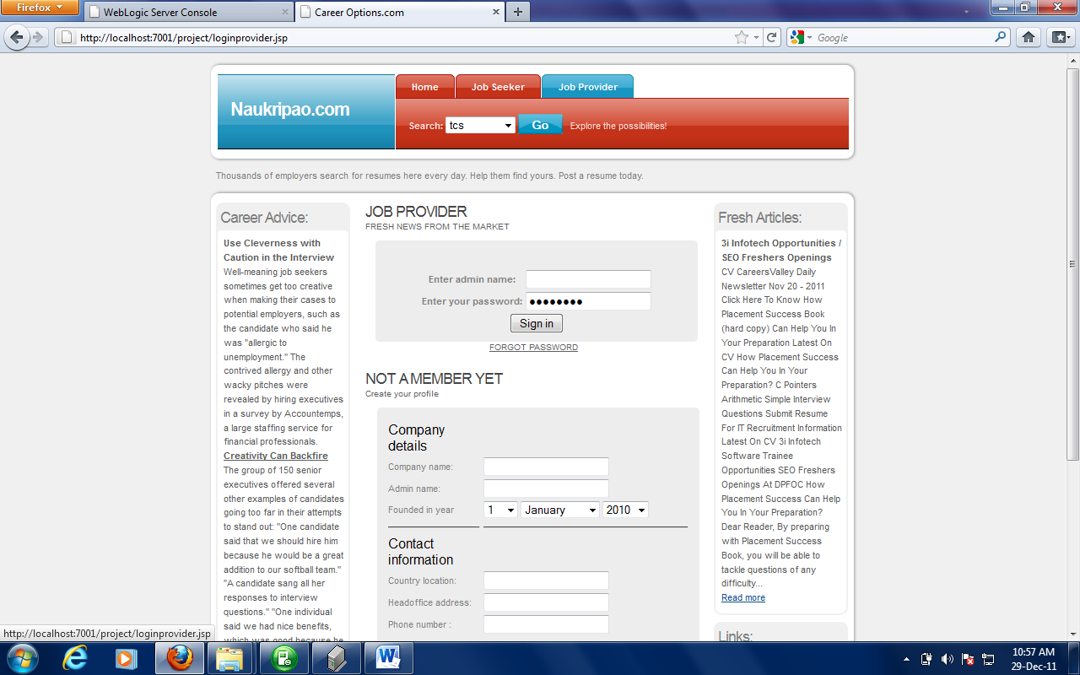

**Job Seeker Home page:**

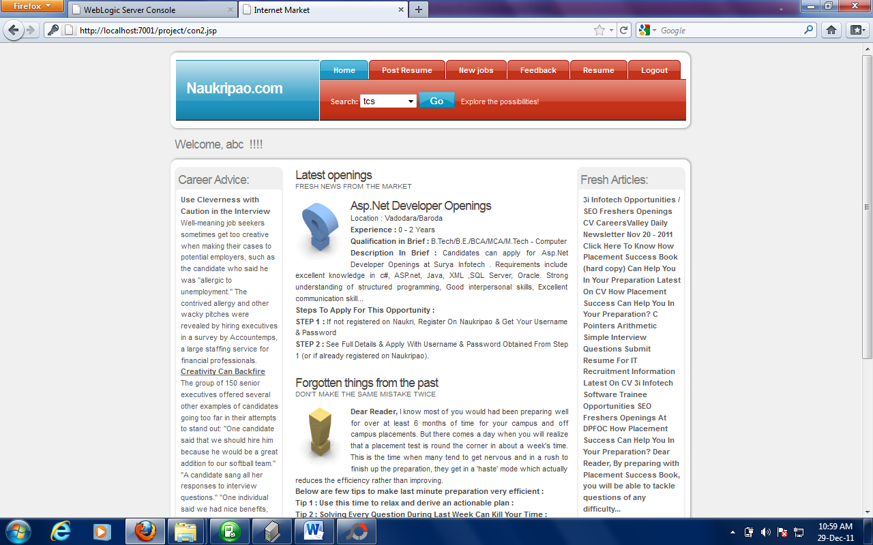

**Upload Resume Page**



**New Jobs Page:**

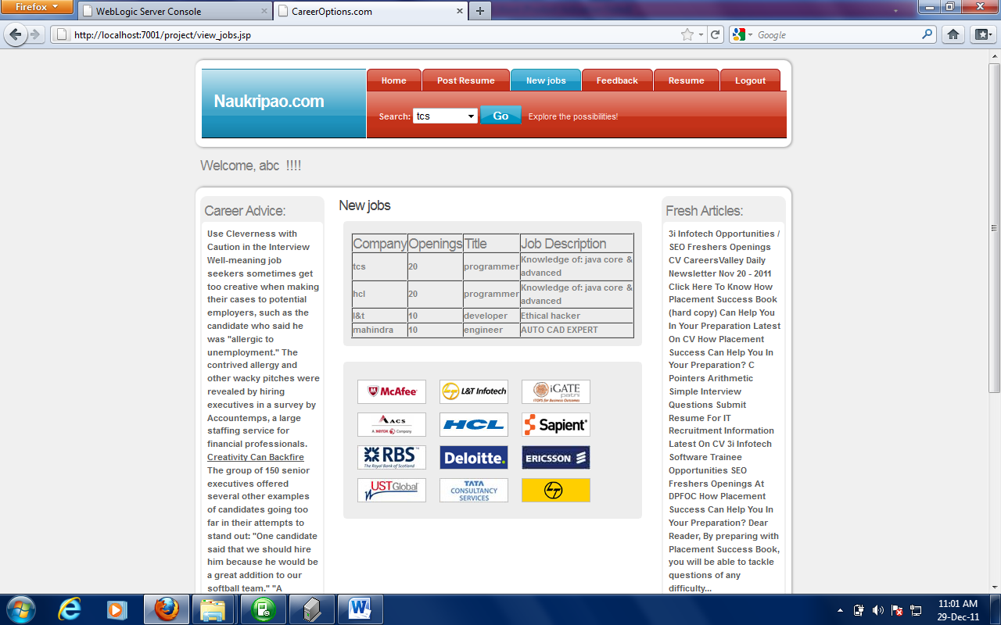

**Feedback Page**

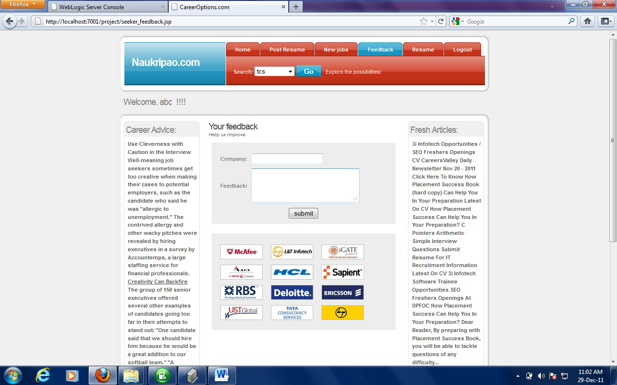

**Resume viewer page:**

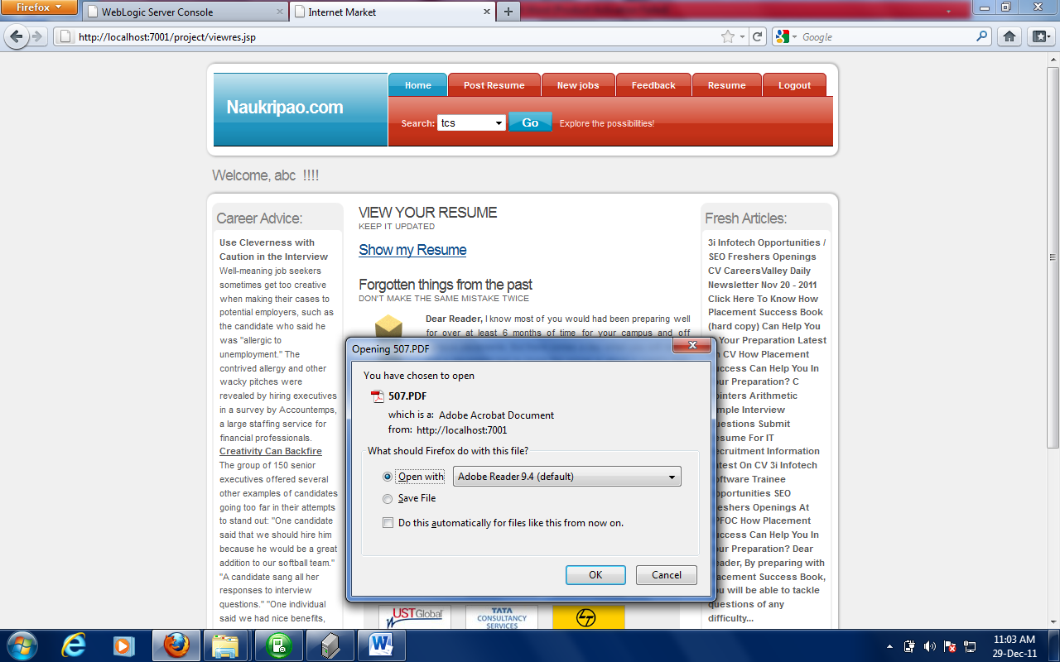

**Job Provider home Page:**

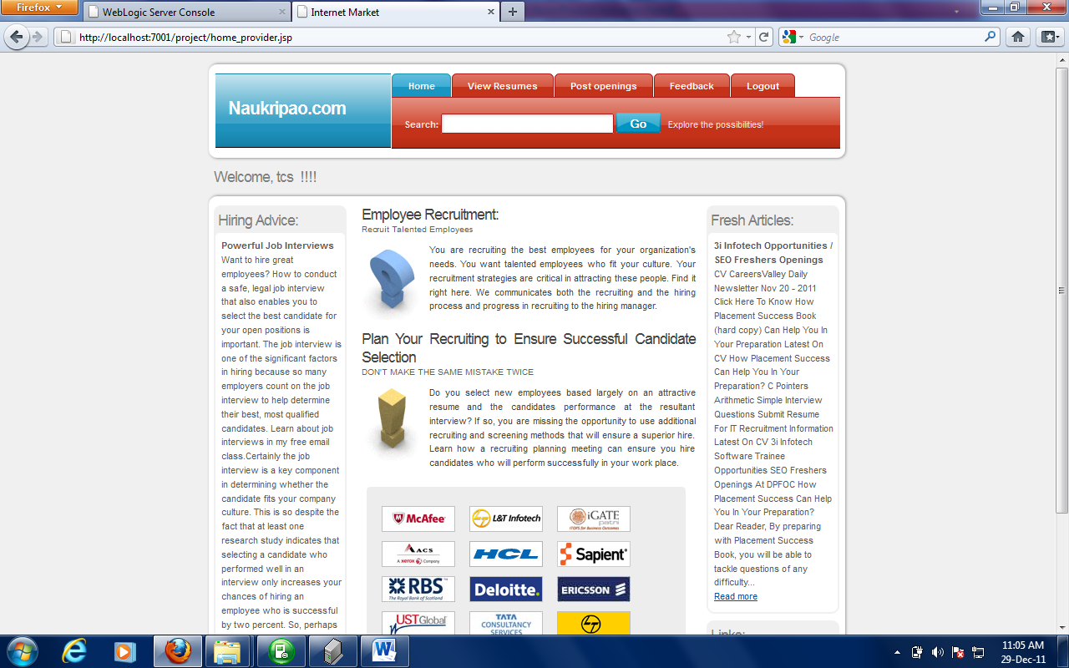

**Resume Viewer:**



**New openings submission page:**

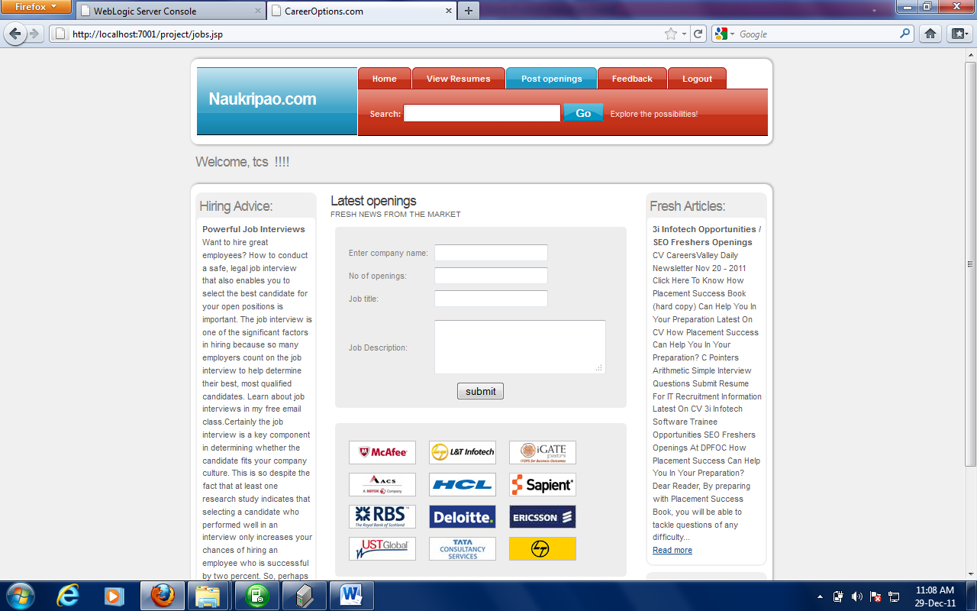

**Job provider feedback page:**

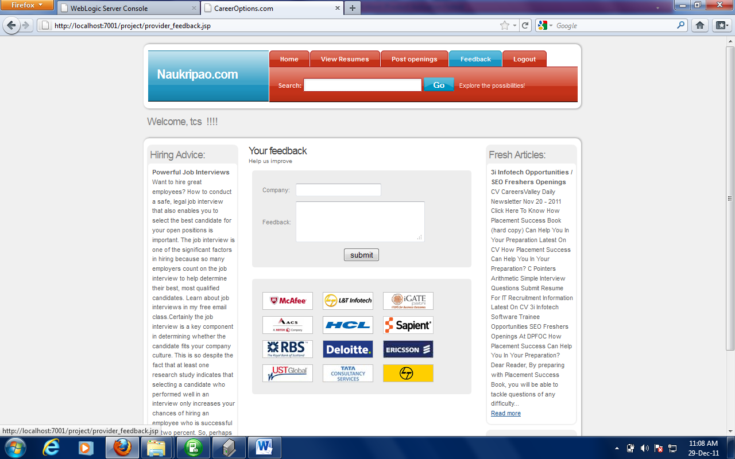

**Logout Confirmation page for job provider**

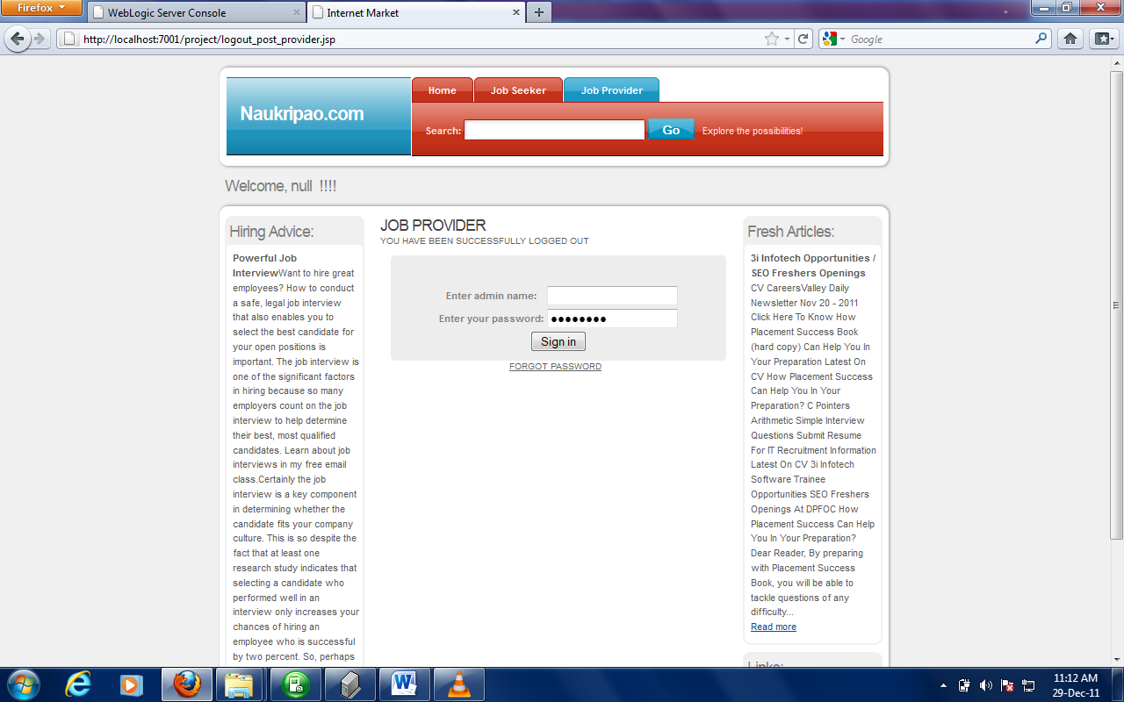

**BIBLIOGRAPHY**

**BIBLOGRAPHY**

The following books were referred during the anylysis and execution phase of the project

### [Head First Servlets *and* JSP*, 2nd Edition*](http://www.google.com/url?sa=t&rct=j&q=&esrc=s&source=web&cd=2&ved=0CDIQFjAB&url=http%3A%2F%2Fshop.oreilly.com%2Fproduct%2F9780596516680.do&ei=IW_7TvSNOYHZrQfO8OH_Dw&usg=AFQjCNEN5AJkMT5ZhrXQXh2hxrkmdn1Efw&sig2=2uitYhGTgN88FXXt3EXKQw)

### [O'Reilly Media](http://www.google.com/url?sa=t&rct=j&q=&esrc=s&source=web&cd=2&ved=0CDIQFjAB&url=http%3A%2F%2Fshop.oreilly.com%2Fproduct%2F9780596516680.do&ei=IW_7TvSNOYHZrQfO8OH_Dw&usg=AFQjCNEN5AJkMT5ZhrXQXh2hxrkmdn1Efw&sig2=2uitYhGTgN88FXXt3EXKQw)

**SOFTWARE ENGINEERING**

By Roger.S.Pressman

**MySQL FOR PROFESSIONALS**

By Jain

**Pure JSP**

By James Goodwill

**Core Servlets and JavaServer Pages**

By Marty Hall